Appointments
GP Registrars
We would like to welcome Dr Ramona Knox to the Practice who is doing her general practice training with us until autumn 2018. Registrars are fully qualified doctors with a great deal of hospital experience and are supported and supervised by one of our GP trainers.
  - Spring 2017 Newsletter

binscombe medical centre
When all of our ‘book on the day’ appointments have been booked, the practice will revert to our telephone triage system so that patients can be prioritised according to clinical need. You will be asked for a contact telephone number so that the duty doctor can call you (sometimes within a few minutes, and we would hope always within 2 hrs). The duty doctor will discuss the issue with you and decide what the best action to take is. The matter may be resolved on the telephone, if not the duty doctor could arrange for you to be seen that day or they could agree with you to make an appointment for another day with your usual doctor if appropriate.

Missed appointments
Please help us to help you by cancelling your appointment if it is no longer required. The practice offers a text appointment reminder service which is helping to reduce the number of missed appointments so that they can be offered to other patients. If you would like to receive appointment text reminders, please ask at reception when you next visit us.

walking for health

Working with the excellent charity Walking for Health (which is run by the Ramblers and Macmillan Cancer Support), the practice has set up a regular walking group. We are very enthusiastic about the value of regular exercise in helping people to stay well, improve their health if they have been unwell and just generally feel good. The walking group has had an excellent turn out and the feedback has been positive. The walking group meets at the Tennis Courts, Lower Car Park at Broadwater on Tuesdays. If you would like to join in, new walkers are asked to meet there at 10.15am

Patient Online Access
Patients can now book appointments, order repeat prescriptions and view parts of their medical records including immunisations, coded consultations, test results, medications, allergies, booked appointments. If you would like to have online access, please see reception or our website for more information.
Online Access & Confidentiality

electronic Prescribing Service (EPS)
This is a facility that allows us to process repeat prescriptions electronically to your pharmacy of choice. Many patients are finding this service extremely convenient. Patients need to sign up to this service and nominate a pharmacy of choice. The pharmacy does not have to be local to your home address, for example you may find it more convenient to nominate a pharmacy local to where you work. Please speak to your chosen pharmacy about this service.

It is important that patients keep their password details private as allowing someone else to use your password, even to book an appointment for you, will give them access to your medications and (if you have requested access) to read parts of your medical record.
Change of Personal Details
If you change your name, address or telephone number, please give full details at reception including your postcode and mobile number if you have one.

Carers
Are you a carer? If you are a child or adult and look after a relative, friend or neighbor who could not manage without your help because of long term sickness, age or disability – and the care you provide is unpaid… you are a carer. Please let us know that you are a carer by completing the carers registration form so that we can ensure you have access to further support. Please ask at reception.
Travel Vaccinations
Please make an appointment at least 8 weeks prior to your holiday to ensure adequate cover. A charge will be made for certain immunisations and vaccinations that are not covered by the NHS.

Do You Check Your Blood Pressure?
If you monitor your own blood pressure at home and have not given us your readings for the last 6 months-please could you drop in your latest readings? The practice also

has a blood pressure machine in the waiting room which was funded by a donation to the surgery. Please feel free to use this machine and hand your readings to the receptionist.
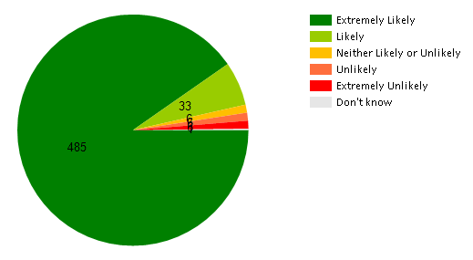
Family and Friends Test (FFT)
We would very much like to know what you think about the practice, so that we know what we do well, and what we could do better. If you are a patient at Binscombe and would like to feedback about your recent experience at the surgery then please answer the Friends and Families question, and also leave us your comments. There are several ways you can feedback to us:

⇒ Go to www.mygpfeedback.com select our practice (Binscombe Medical Centre) and complete the questions
⇒ Text the word BINSCOMBE to 07860 035936 and answer the questions that are sent. Standard message rates will apply.
⇒ Ask at reception for a paper form for you to complete by hand and leave with reception after your visit to the practice

The FFT asks “How likely are you to recommend the GP surgery to friend and family if they needed similar care or treatment?” The results for the last 12 months are as follows:

New NHS study seeks recruits for ground-breaking dementia study
Recruits are being sought for a major new dementia study that aims to improve the lives of people with dementia and their carers using cutting edge technology.
The study, TIHM (Technology Integrated Health Management) for dementia is being led by Surrey and Borders Partnership NHS Foundation Trust and is funded by the Department of Health. A key partner in the study is the Alzheimer’s Society.
The aim of TIHM for dementia is to support people with mild to moderate dementia to stay safe and well in their homes and to reduce some of the pressure on carers.
The technology involves a network of small technological devices, connected using the Internet of Things, that are installed in a person’s home. These devices allow clinicians to remotely monitor a person’s health, wellbeing and environment round the clock and in real time.
If the technology identifies a health or safety problem, clinicians will be immediately alerted and will decide on the support needed. This may involve calling the carer to advise them of a concern, organising a GP appointment, arranging for an Alzheimer’s Society Dementia Navigator to visit or, if necessary, contacting the emergency services.
Surrey and Borders Partnership is recruiting 700 people with dementia and 700 carers to participate in TIHM for dementia. The study is designed to work alongside a person’s existing care and will not replace any help that is already being received. To participate in TIHM for dementia, a person must have a diagnosis of dementia (mild to moderate) and live in Surrey or North East Hampshire. They must also have a carer, who can be a partner, relative, friend or paid carer who is willing to get involved. To find out more about the study and how to sign up, go to: www.sabp.nhs.uk/tihm or call 01932 722247.

Confidentiality
All information about you is held securely. From time to time information may be shared with others involved with your care if it is necessary. In certain circumstances you will be required to give written consent before information is released – such as medical reports for insurance, solicitors etc. PLEASE be aware therefore that we cannot discuss your medical records which includes confirming your appointments with family members without your written consent to do so. We sometimes get phone calls from family members wanting to confirm an appointment or get results of recent tests but we are unable to give this information to them unless we have patient consent. If you wish to give consent for this information to be released to a family member , please provide us with written consent confirming what information we are allowed to discuss and with whom.
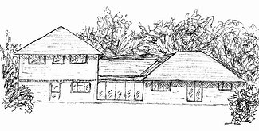
When we are closed
A&E should not always be the first point of call when we are closed and should only be used when there is a genuine emergency. Please phone NHS 111 when the surgery is closed. You can call 111 when you need medical help fast but it’s not a 999 emergency. In a genuine emergency, you should always call 999. If you need your regular medication when we are closed, please try the pharmacy where you usually get your medications in the first instance. You can also speak to your pharmacist for advice if needed.

